|  |
| --- |
| **Question 1 Document** |
| **JMC MUSIC PLAYER** |
| Programming III |

|  |
| --- |
| Jose Rico Imbang  26/11/2020 |

# TABLE OF CONTENTS

1 What data structure are you using? 1

2 Where are you using hashing techniques? 1

3 What sorting algorithm are you using? How is this different from selection and bubble sort? 1

4 What search technique are you using? 1

5 What third party libraries are you using? 2

6 Where can I find the documentation for this? 2

7 A mock-up of the GUI. 2

8 What source control are you using? 3

9 What coding standards are you enforcing? 3

10 What tests are you going to run? 4

### 1 What data structure are you using?

The data structure that I am using is AVL Tree. This tree is balanced at all times which means that the height of the left sub-tree and the height of the right sub-tree can only differ by at most 1.

### 2 Where are you using hashing techniques?

A user can use the JMC Music Player through the client application. The user is required to log in to be able to use the JMC Music Player. The client application sends the login details to the server application. The server application hashes the password once it receives the login details then verifies whether the user enters the correct details.

### 3 What sorting algorithm are you using? How is this different from selection and bubble sort?

Bubble sort finds the highest value and put it at the end of the data set or where that value belongs by comparing each pair of elements in the data set. It sorts from highest to lowest.

Selection sort on the other hand goes through all the elements in a data set one-by-one, comparing the value of one element to the next checking which is smaller. It then saves the smallest element found in a variable and when the iteration is complete, it will insert that saved element into its respective position in that data set swapping positions with the value in that position.

Merge sort is a bit more complex compared to Bubble sort and Selection sort, but it is more efficient. Merge sort divides that data set into smaller data sets, sort those smaller data sets then join them together. This algorithm sorts the right side after the left side of the data set is sorted.

### 4 What search technique are you using?

Since the data structure that I am using is an AVL Tree, I decided to use binary search as my searching algorithm. Binary search algorithm works perfectly with AVL Tree since the latter is also a Binary Search Tree.

### 5 What third party libraries are you using?

The third-party library that I am using is a CSV Reader.

### 6 Where can I find the documentation for this?

The documentation for the CSV Reader can be found from this link: [A-Fast-CSV-Reader](https://www.codeproject.com/Articles/9258/A-Fast-CSV-Reader)

### 7 A mock-up of the GUI.

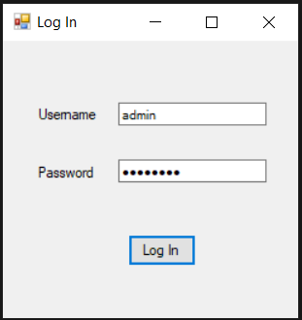

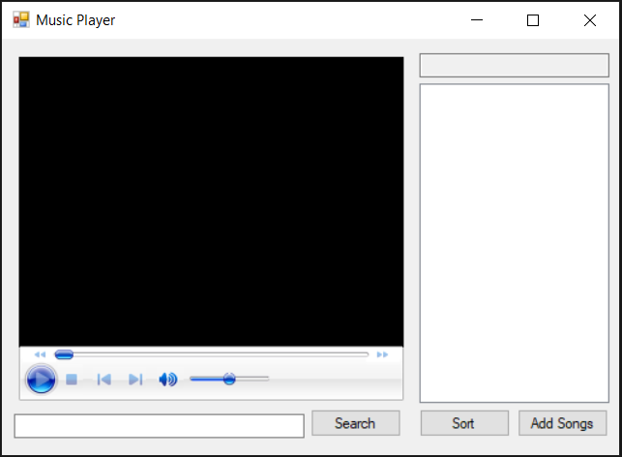

### 8 What source control are you using?

The source control that I am using is Git. It is used to monitor the changes that are made when developing an application. This is extremely helpful especially in a team where different members work together. Let’s say a team of two is working on a project. The first programmer writes his own code while the other writes his own. By using Git, they are able to keep a copy of the original file while both programmers are adding some features on it. In case one of them doesn’t like the new feature, they can go back to the original file or add the feature that they like. Then from here, they can continue the development.

### 9 What coding standards are you enforcing?

The coding standard that I am using is C# Coding Conventions. I am using this coding standard to create a consistent look to the code so that readers can focus on content a not on layout. This also helps facilitate copying, changing, and maintaining the code. Click the link to know more about [C# Coding Conventions](https://docs.microsoft.com/en-us/dotnet/csharp/programming-guide/inside-a-program/coding-conventions).

### 10 What tests are you going to run?

The tests that I am going to run are the following:

* User can log in using the correct credentials
* User is prompted if the login information is incorrect
* User can to play a music
* User can search a specific music
* Searched track is highlighted
* User can sort the list of music
* User password is hashed